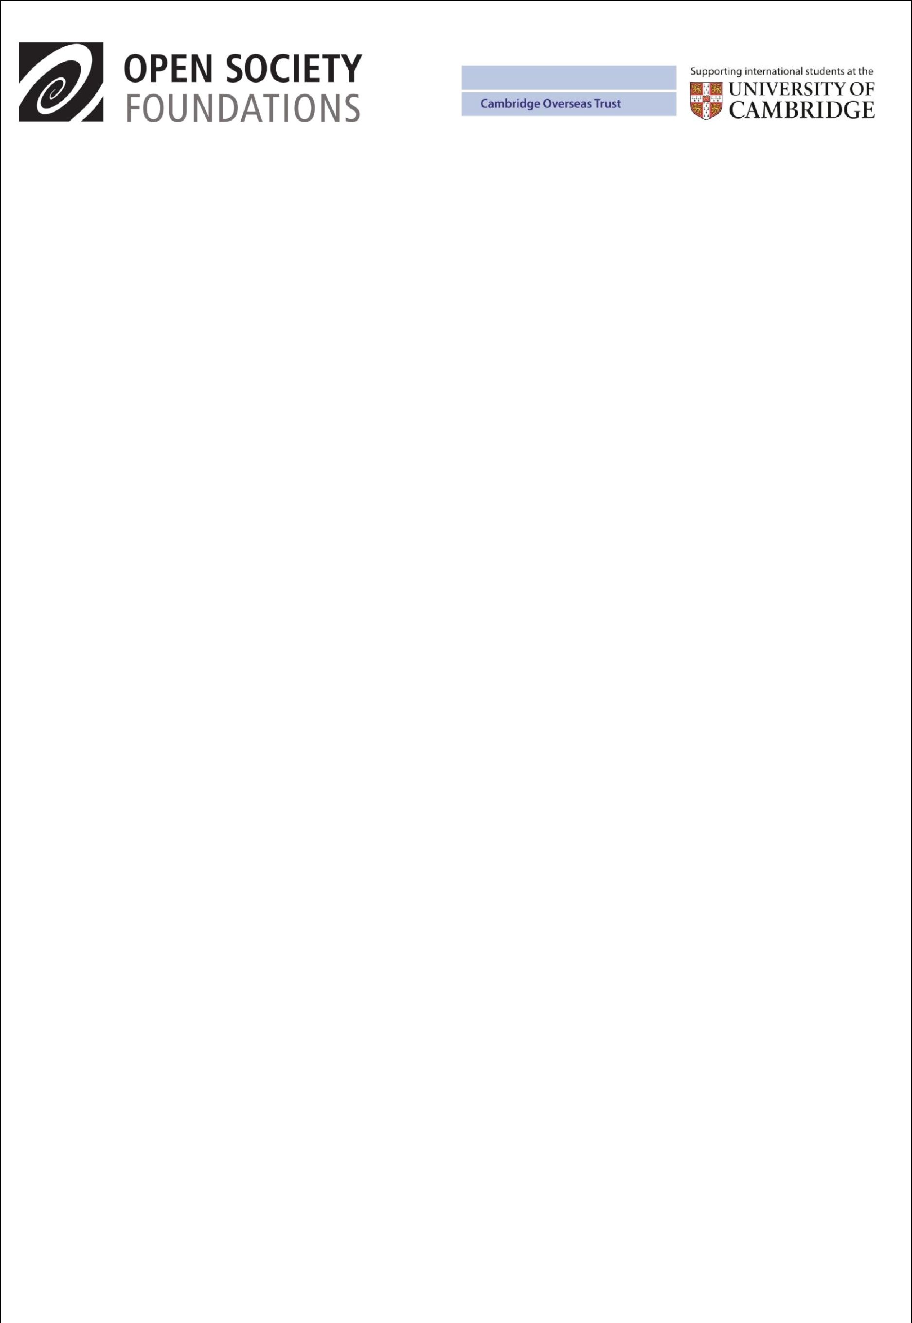

Open Society Foundations / Cambridge Scholarships 2013-14
The Open Society Foundations, in partnership with the Cambridge Overseas Trust, offer outstanding students an opportunity to study at the University of Cambridge, UK, through a jointly-funded scholarship programme – the Open Society Foundations / Cambridge Scholarships.

Why study at the University of Cambridge?

- the University is regularly ranked as one of the best in the world – first in the QS World Universities Rankings in both 2010 and 2011

- its teachers and researchers are world-leading experts, and the University offers superb resources and facilities

- a degree from Cambridge will enhance your future career, and provide a network of contacts and friends that will remain with you for life
Who can apply?
- citizens and residents of Moldova

- candidates for a one-year postgraduate Masters degree in the following subjects:

MPhil in Conservation Leadership
MPhil in Environment, Society and Development
MPhil in Multi-disciplinary Gender Studies
MPhil in Environmental Policy
MPhil in Development Studies

MPhil in Public Health
MPhil in Education
LLM in Law

What are the main criteria for receiving a scholarship?
- intellectual ability and leadership potential

- a good degree (at least equivalent to upper 2nd class) from a recognised university

- apply by the deadline and gain admission to the University of Cambridge

- a high level of English language skill

- intention to return to home country after study at Cambridge
What will the scholarship pay?
- tuition fees, College fee, annual stipend (sufficient for a single person), return airfare

- Open Society Foundations also invite all successful applicants to a pre-academic Summer School
How can I apply?

- check out the relevant courses on the University of Cambridge website www.admin.cam.ac.uk/students/gradadmissions/prospec/

especially the admission and English language requirements

- contact your local Open Society Scholarship Programs representative:
Educational Advising Center

str. Puskin, 16, Chisinau, MD 2012 Tel/Fax: (373 22)221167, (373 22)221172 Email: eac@eac.md

Contact person: Angela Muset, Scholarship Program Director: amuset@eac.md

- then submit the scholarship application form http://www.eac.md/scholarships/soros/camb/index.html to your local representative by the deadline 15 November 2012 – no late applications will be accepted

- following this you will receive a voucher code by email from the University of Cambridge for the online application payment; you must then submit an online application to the University of Cambridge www.admin.cam.ac.uk/students/gradadmissions/prospec/apply/index.html

by the deadline of 4 December 2012 – no late applications will be accepted.

PDF to Word

